

12

19

-Custom List View (2 hours)

-Custom List View Items (2 hours)

-Custom List View Adapter (3 hours)

-List View Delete Function (2 hours)

-Display More Item Info (2 hours)

-Array Adapter (2 hours)

-SQLite Remove Function (3 hours)

-SQLite Read Function (3 hours)

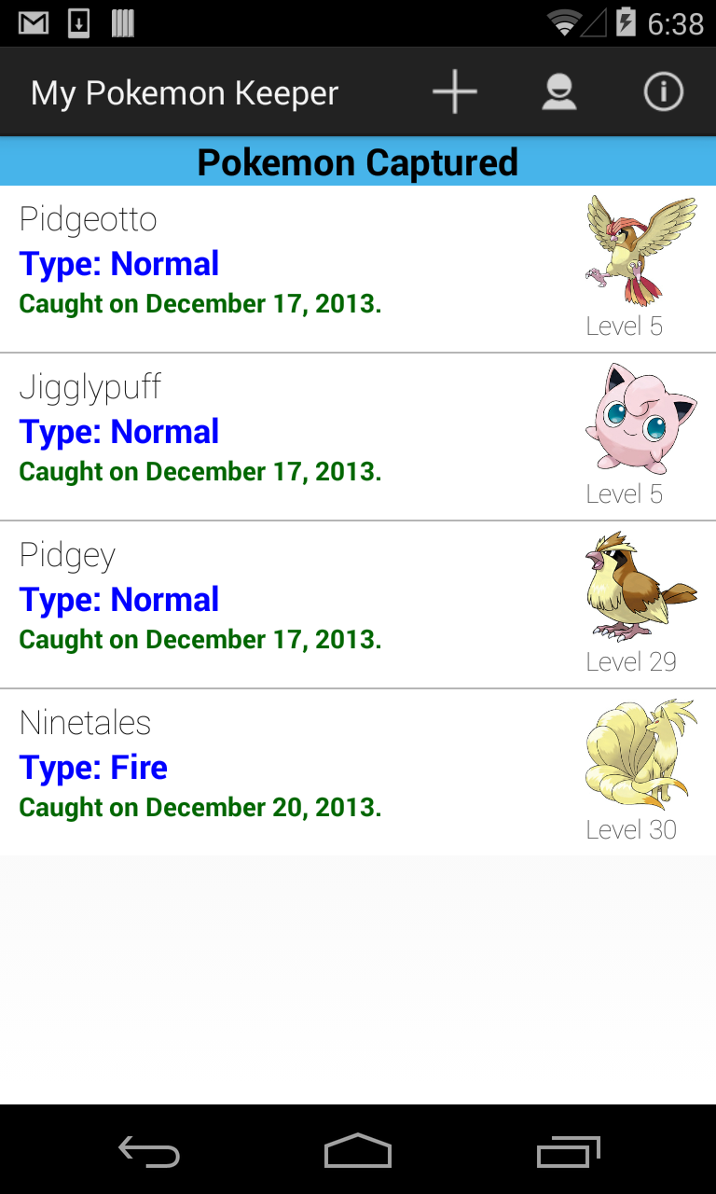

Progression Summary



Visual Progression (if applicable)

Fill out one form per feature (not activity). In the Visual Progress pane, try and outline any progress you will have made to features that affect the visual display of the app - UI Views, Navigation Controls, etc. Don’t show the entire screen (unless applicable), concentrate on the feature.

Expected Functionality



The user will be able to view the information of their captured Pokémon. The user will also be able to delete a Pokémon from their list.

Details & Status

CapturedList

Custom ListView

0

Activity

Feature

Est. Hours

Completed

0

Actual

12/17/2013

Components

Changes & Outcomes



Creating the SQLite database was the easiest part. The main problem was displaying the images, and creating the custom list view. I had an issue with getting the ID of each item, which had caused issues to the delete function. All issues were resolved.